Introduction:

This project introduces a comprehensive fitness and wellness tracking application designed to meet the growing need for simple, meaningful, and user centered health management. Many individuals struggle to maintain consistent routines because their health information is scattered across multiple apps, each focusing on only one part of their lifestyle. This application brings everything together by integrating physical activity tracking, nutrition monitoring, and wellness insights into a single, accessible platform. The goal is to give users a clear understanding of how their daily choices influence their long term well-being and to help them make informed decisions through organized, data driven feedback. By presenting information in a way that is easy to understand and personally relevant, the app aims to reduce confusion, increase awareness, and support healthier habits.
Beyond tracking numbers, this project focuses on motivation, accountability, and long term engagement. Many people begin their health journey with excitement but lose momentum when progress becomes difficult to see or understand. This application addresses that challenge by offering personalized recommendations, visual progress indicators, and meaningful insights that encourage users to stay committed. Our team plans to make tracking your health successful by creating an experience that feels supportive, intuitive, and genuinely helpful. By combining fitness, nutrition, and wellness into one cohesive system, the project aims to provide a tool that not only records data but actively guides users toward a healthier and more balanced lifestyle. Below are examples of a Fitness & Wellness Tracker:

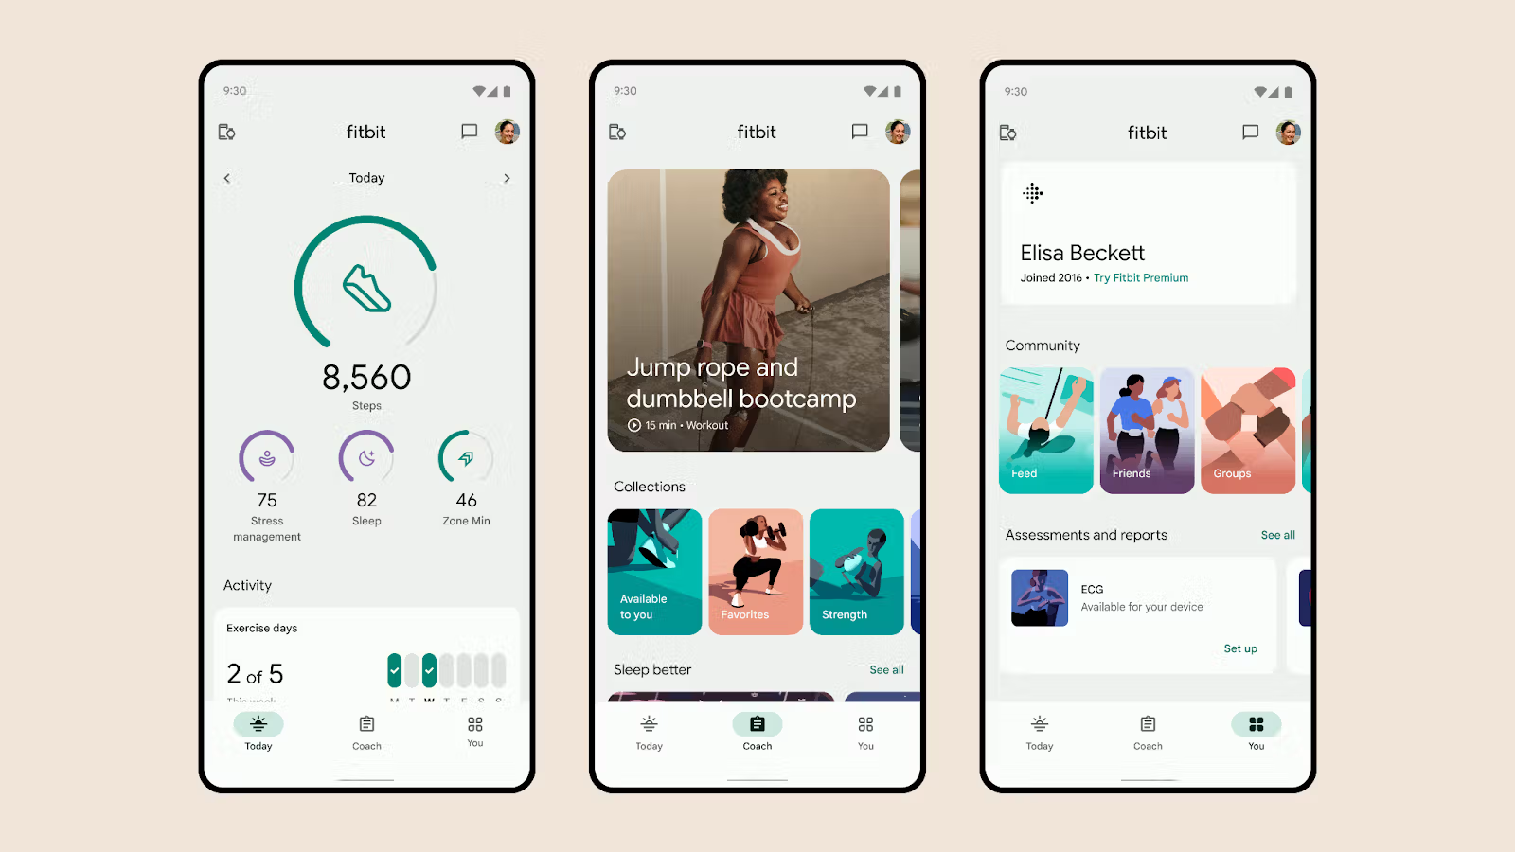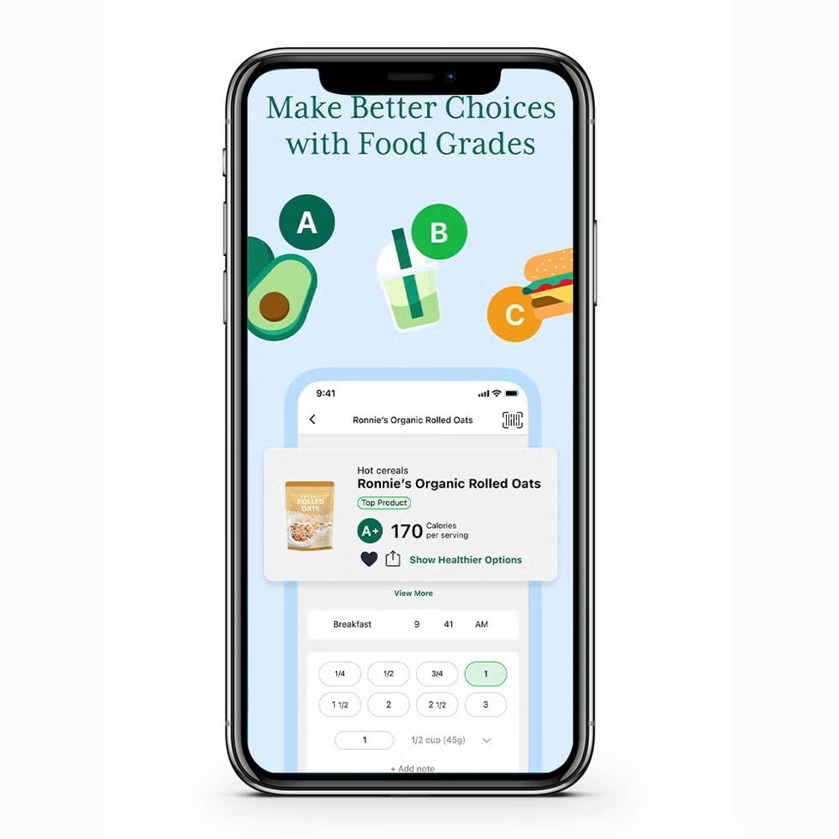

Project Organization:

Position | Names | Description
Group Leader | Emily | Oversees team coordination, deadlines, communication, and project direction.
Designer | Deishaneigh, Bithiah | Creates UI layouts, visual design, and ensures the app is user‑friendly.
Coders / Programmers | Abdallah, Emily, Bithiah | Build the app’s features, database, and functionality.
Organizer | Emily, Deishaneigh | Manages schedules, meetings, and keeps project materials organized.
Testers | N/A | Will test features, find bugs, and ensure smooth performance.
Documentation | Bithiah | Will maintain written documentation and project records.

Risk Analysis:

Risks | Risk Level | Risk Planning
Incomplete or Late Delivery  This risk involves the project not being finished by the due date. The workload, unexpected issues, or delays could slow progress. | Moderate | The team will follow a realistic schedule, hold weekly check-ins, and prioritize core features to stay on track.
Data Loss or Cloud Storage Failure  Project files or user data could be lost if cloud services fail or files become corrupted. | Low | The team will keep multiple backups, use GitHub regularly, and store important files in more than one location.
Team Member Unavailability  A team member may become unable to participate due to illness, emergencies, or schedule conflicts. | Moderate | Documentation will be kept updated so tasks can be transferred if needed, and responsibilities will be shared when possible.
Too Many Features  The team may try to add more features than originally planned, which could delay the project or leave parts unfinished. | High | The project scope will be clearly defined early, and no new features will be added without group approval.
Technical Issues  Development tools, databases, or the app itself may crash, break, or fail to function correctly. | Moderate | The team will use reliable tools, save work frequently, and reinstall or switch tools if problems occur.
Incomplete Testing / Bugs  Not enough time for testing may result in bugs, inaccurate tracking, or broken features. | High | Testing will begin early, and each feature will be tested as soon as it is built to avoid last-minute issues.

Hardware & Software Requirements:

Hardware Requirements

- A laptop or desktop computer capable of running development tools
- Reliable internet connection for collaboration and version control
- Mobile device (Android or iOS) for testing the app interface
- External storage or cloud storage for backups
- Optional: second monitor to improve workflow and multitasking

Software Requirements
- Visual Studio Code or Android Studio for development
- GitHub for version control and team collaboration
- Firebase or SQLite for database management
- Figma or Canva for UI/UX design and wireframing
- Web browser for research, documentation, and testing
- Communication tools such as Microsoft Teams or Google Chat
- Microsoft Word for documentation and reporting

Case Diagram:

Fitness & Wellness App

Log Workout
Log Meals

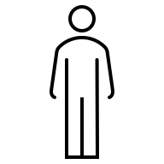
User
View Daily Summary

Receive Wellness insights
Track Progress

Class Diagram:

